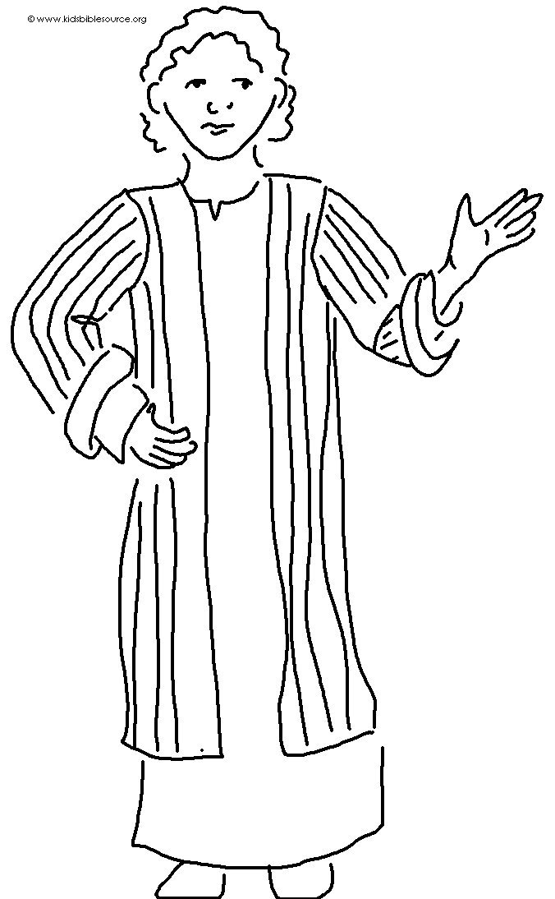
Jesus said,
"I am with you _ _ _ _ _ _…"
Matthew 28:20

